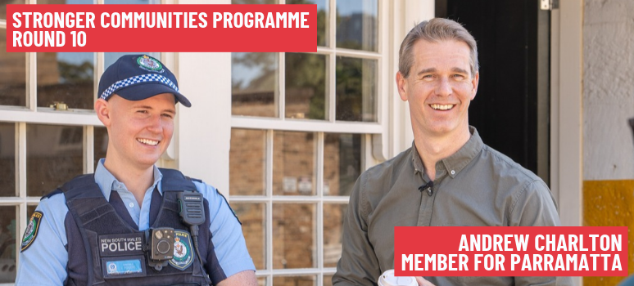
Parramatta Expression of Interest Form
Expressions of Interest submissions close 5pm, Saturday 14 November 2026. Please return to Andrew.Charlton.MP@aph.gov.au by the closing date to be considered for funding.

- ORGANISATION DETAIL
Organisation Name  Where you have a sponsor arrangement, this must be the name of the sponsor organisation who is eligible to apply. | [Click here to enter text]
ABN | [Click here to enter text]
What type of entity are you?  You may be required to provide proof of incorporation if applicable. | ☐ Incorporated Not-for-profit Organisation  ☐ Non-distributing co-operative  ☐ Company limited by guarantee  ☐ Australian Indigenous corporation  ☐ Religious organisation incorporated under legislation  ☐ Incorporated trustee on behalf of a trust with responsibility for a community asset or property  ☐ State government agency that is a fire service, country fire authority, state emergency service or similar  ☐ Local Governing Body e.g. Local council (This will limit your grant to 50% of eligible project expenditure)
Are you a trustee on behalf of a trust?  If yes, please provide both the Trust and the Trustee’s ABN. | [Select Yes or No]  Trust ABN: [Click here to enter text]  Trustee ABN: [Click here to enter text]
Are you a charity registered with the Australian Charities and Not for-profits Commission (ACNC)? | [Select Yes or No]
Are you registered for GST? | [Select Yes or No]
Organisation street address  Please provide a street address, not a post box address. | [Include Address Line 1, Address Line 2, Suburb, State, Postcode]
Organisation postal address  You may provide a post box address here. | [Include Address Line 1, Address Line 2, Suburb, State, Postcode]
Sponsored organisation (where applicable)
Are you applying as a sponsor  on behalf of an unincorporated  organisation? | [Select Yes or No]
Sponsored organisation name | [Click here to enter text]

- NOMINEE CONTACT DETAILS
Name | [Click here to enter text]
Position in organisation | [Click here to enter text]
Email address | [Click here to enter text]
Telephone number  Mobile number (optional) | [Click here to enter phone number]  [Click here to enter mobile number]
Address  Enter ‘as above’ if using the organisation address | [Include Address Line 1, Address Line 2, Suburb, State, Postcode]

- PROJECT INFORMATION
Project title | [Click here to enter text]
Project description (200 words)  What the key project activities that you will be  using the grant funds for? | [Click here to enter text]
Objectives (200 words)  Please refer the Grant Opportunity  Guidelines. List the objective or objectives  you have chosen from section 2.2 of the  guidelines that your project supports. | [Click here to enter text]
Aligning activities (200 words)  Please refer the Grant Opportunity  Guidelines. List the eligible activity or  activities under the chosen objective or  objectives in the table in section 5.1 of the  guidelines that your project aligns with. | [Click here to enter text]
Project outcome/why is the project important? (300 words)  Explain how your project supports and  encourages local community participation and  delivers social benefits to the local community. | [Click here to enter text]
Project site location  Please ensure this street address is within the  nominating electorate.  % of project value undertaken at site | [Include Address Line 1, Address Line 2, Suburb, State, Postcode]  [Click here to enter %]
Total cost of project  Minimum $2,500 (LGAs minimum $5,000) and maximum $50,000 | [Click here to enter $ amount]
Grant funding sought  Local Governing Bodies (LGAs) can only apply  for a grant amount of 50% of eligible project  costs. LGAs must provide matched funding  contributions towards their eligible project. | [Click here to enter $ amount]
Can you complete the project by 31st March 2028? | [Select Yes or No]

